Business Model Canvas: EasyInsure

**1. Key Partners**

* Tech Providers: AWS Rekognition, Google Maps API
* Service Partners: 🏥 Hospitals, 🔧 Garages
* Regulatory: 🛡️ IRDAI (Auto-Compliance)
* Vendors: Twilio (SMS), NLP Developers (Natural Language)

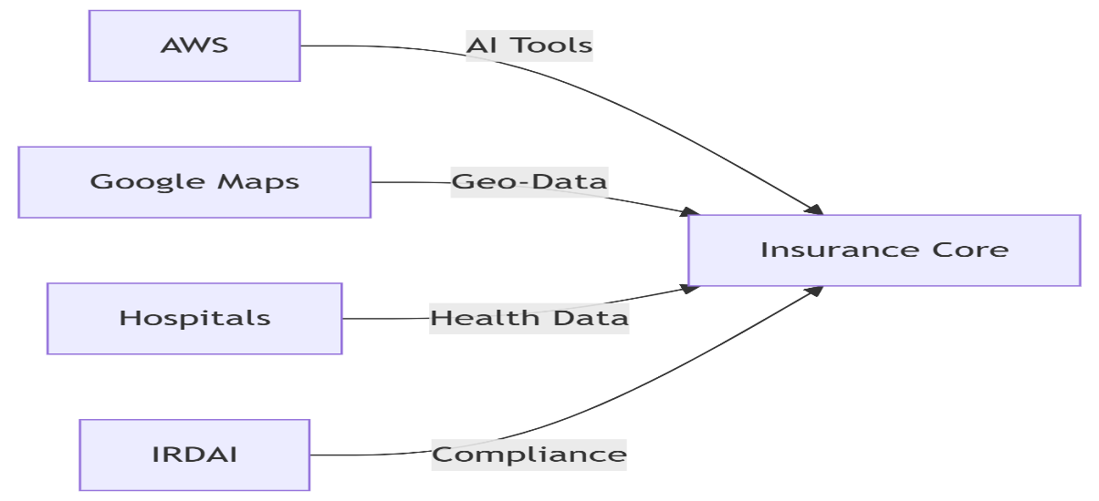

**2. Key Activities**

* AI/ML: Fraud detection 🕵️, Damage estimation
* Real-Time Sync: Garage/Hospital APIs
* Security: 🔒 AES-256 Encryption
* Compliance: Auto-updating IRDAI rules.

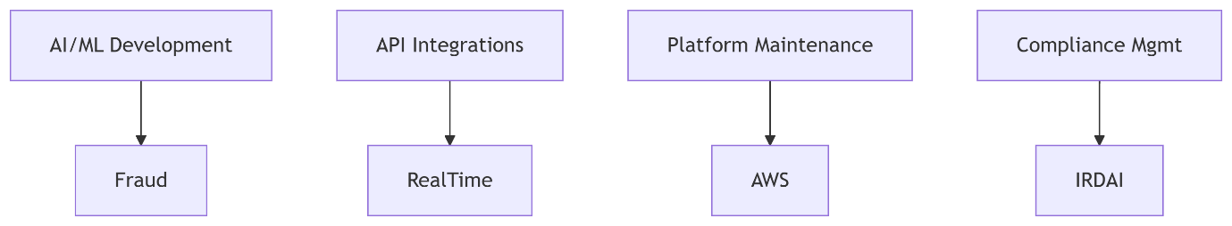

**3. Key Resources**

* Technology Stack: Python, AWS cloud, Power BI.
* Data Assets: Claim histories, customer risk profiles, partner performance metrics.
* Human Capital: AI specialists, data engineers, compliance officers.
* Intellectual Properties: Fraud detection algorithms, dynamic pricing models.

**4. Value Propositions**

* For Policyholders:
* ⚡ Instant Claims (<4 hrs) → 📸 Photo-to-Form Tech
* 📱 WhatsApp Renewal Alerts
* 🎯 Personalized Premiums (Risk-Based)
* For Admins/Partners:
* 📊 AI Dashboards → Fraud Heatmaps
* 🤖 40% Lower Manual Costs

**5. Customer Relationships**

* Self-Service: Mobile app, web portal (policy downloads, claim filing).
* Automated Support: WhatsApp chatbot, in-app video calls.
* Proactive Engagement: Renewal reminders, personalized offers.
* Partner Management: SLA scorecards, feedback sessions.

**6. Channels**

* Digital: Mobile app (iOS/Android), web portal.
* Messaging: WhatsApp, SMS, email notifications.
* Partner Networks: Garage/hospital APIs, reinsurer portals.

**7. Customer Segments**

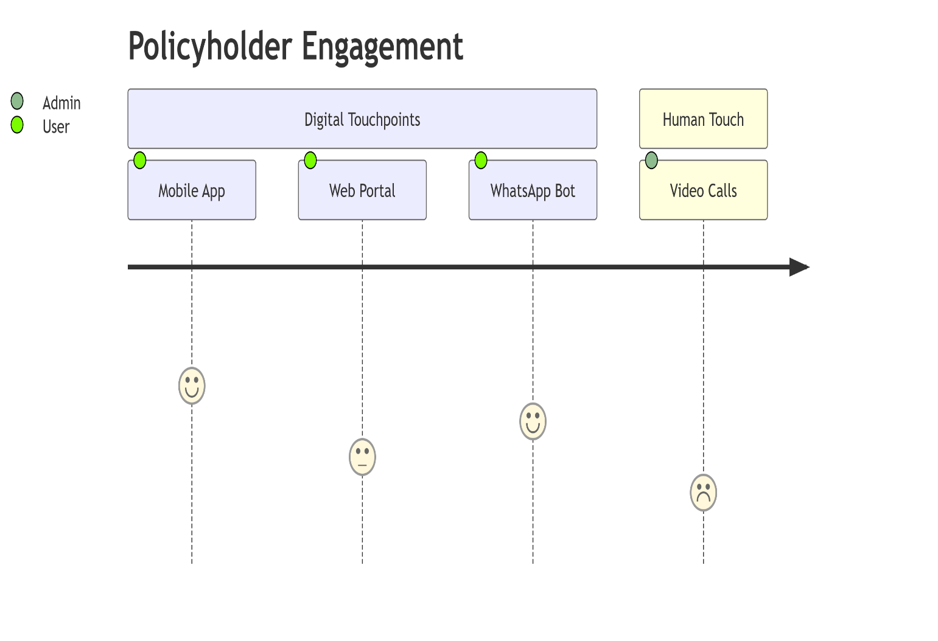

* 👨‍💼 Policyholders (Health/Motor)
* 🏢 B2B Partners
* 👩‍💼 Internal Teams

**8. Cost Structure**

| Area | Allocation | Visual |
| --- | --- | --- |
| Tech Dev | ₹8M AI Budget | ██████▁▁▁ 60% |
| Cloud (AWS) | ₹3M | ████▁▁▁▁ 40% |
| Ops/APIs | ₹2M | ██▁▁▁▁▁ 20% |
| Compliance | ₹1.5M | █▁▁▁▁▁ 15% |

**9. Revenue Streams**

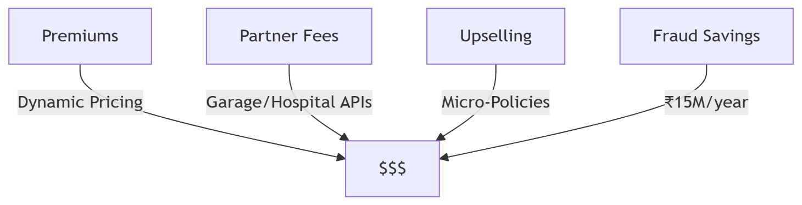

* Insurance Premiums: Dynamic pricing based on risk profiles
* Growth Levers: Pay-per-km Insurance, Fitness Discounts.
* Partner Commissions: Fees from garages/hospitals for API integrations.
* Cost Savings: Fraud reduction (₹15M/year), operational efficiency (20% lower OPEX).
* Upselling: "Rider" add-ons (e.g., zero-depreciation), micro-policies (travel/theft).

**Strategic Highlights**

* Scalability: 500K users | Hindi/Tamil/English 🌐
* AI Advantage:
  + Image Hashing → 30% Fraud Reduction
  + Real-Time Damage Estimation
* Compliance: 7-Year Auto-Audit Logs 📜

**Sources:**

* BRD/PRD (Sections 3–5, 8–10): Target metrics (fraud reduction, TAT), user benefits.
* Scope Sheet (Digital Transformation Goals): AI/analytics use cases.
* Constraints (BRD Section 6): Budget (₹8M), technical dependencies.